Department of Mechanical Engineering

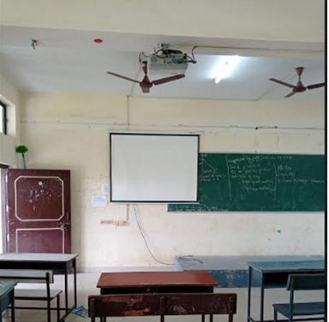
Class room Photo of II Yr - LHE 204

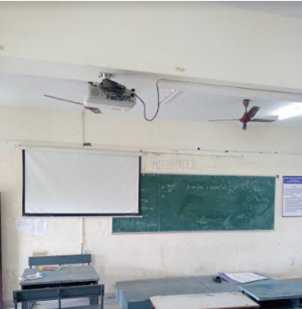
Class room Photo of III Yr ‘A’ Sec -LHE 205

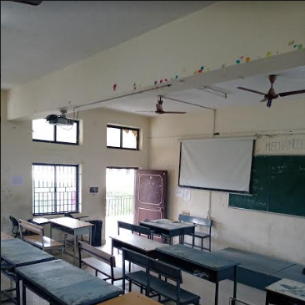
Class room Photo of III Yr ‘B’ Sec -LHE 206

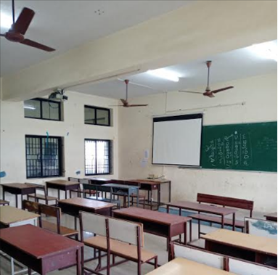
Class room Photo of IV Yr ‘A’ Sec -LHE 207

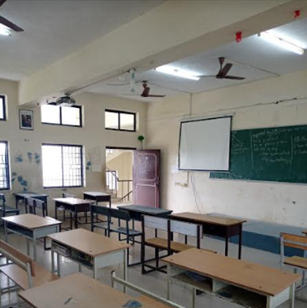
Class room Photo of IV Yr ‘B’ Sec -LHE 208

