Department of Mechatronics Engineering

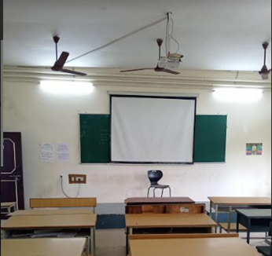
Class room Photo of II Yr - LHE 302

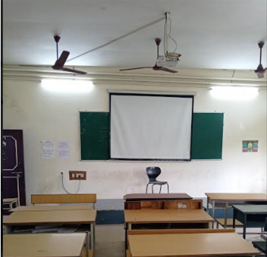
Class room Photo of III Yr VSem- LHE 303

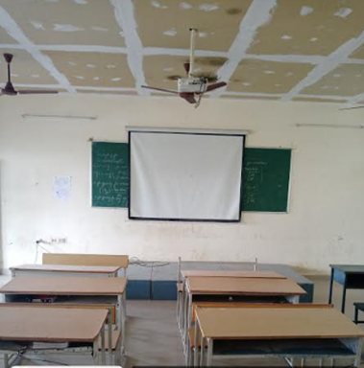
Class room Photo of IV Yr - LHE 304

