Department of Electronics & Communication Engineering

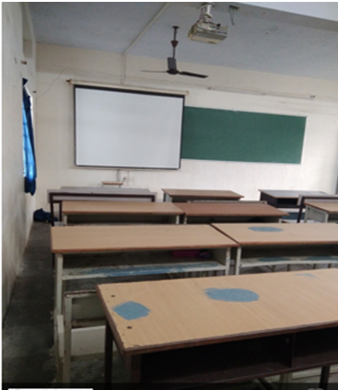
Class room Photo of II Yr ‘A’ Sec -LHS 201

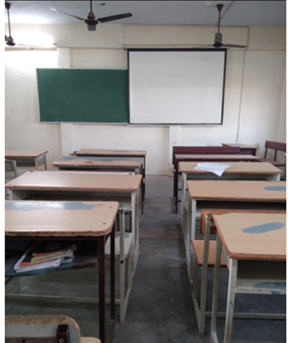
Class room Photo of II Yr ‘B’ Sec –LHS 202

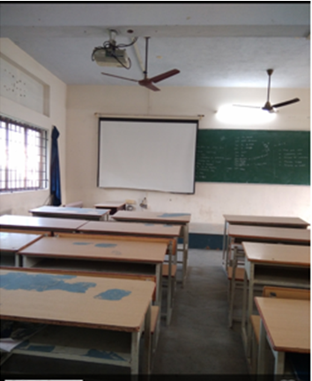
Class room Photo of III Yr V Sem ‘A’ Sec –LHS 203

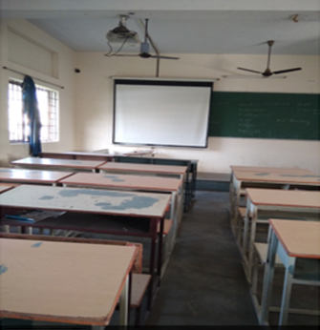
Class room Photo of III Yr V Sem ‘B’ Sec – LHS 204

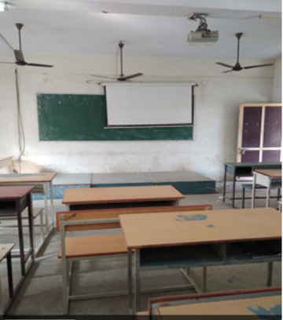
Class room Photo of IV Yr ‘A’ Sec - LHW 201

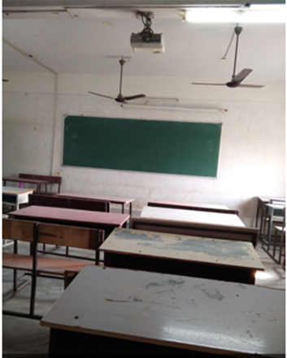
Class room Photo of IV Yr ‘B’ Sec – LHW 202

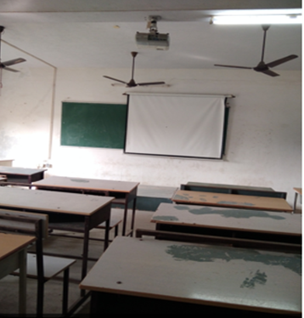
Class room Photo of IV Yr VII Sem ‘C’ Sec - LHW 203

