Department of Civil Engineering

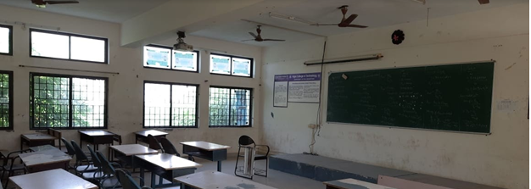
Class room Photo of II Yr - LHN 201

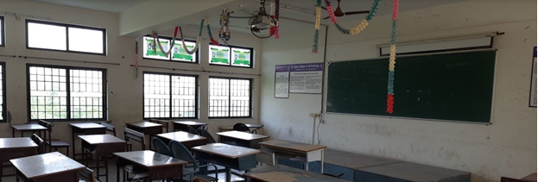
Class room Photo of III Yr - LHN 201

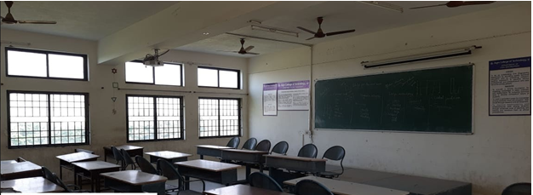
Class room Photo of IV Yr - LHN 201

