Department of Computer Science Engineering

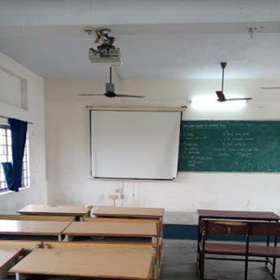
Class room Photo of II Yr ‘A’ Sec - LHS 205

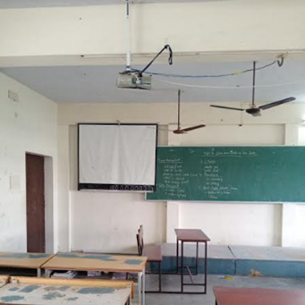
Class room Photo of II Yr ‘B’ Sec - LHS 206

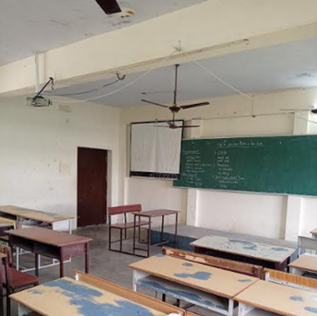
Class room Photo of III Yr ‘A’ Sec - LHS 207

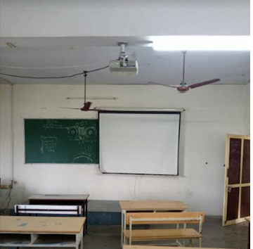
Class room Photo of III Yr ‘B’ Sec - LHS 208

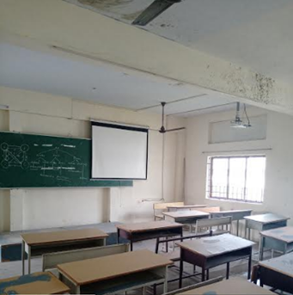
Class room Photo of IV Yr ‘A’ Sec - LHS 209

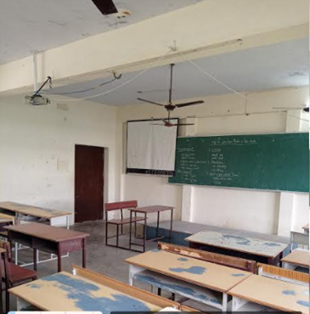
Class room Photo of IV Yr ‘B’ Sec - LHS 210

