Department of Chemical Engineering

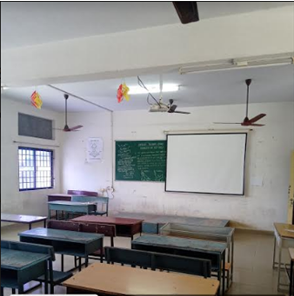
Classroom Photo of II Yr- LHW 208

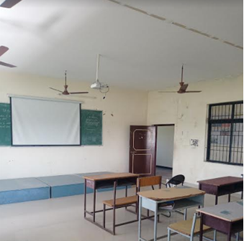
Classroom Photo of III Yr- LHW 304

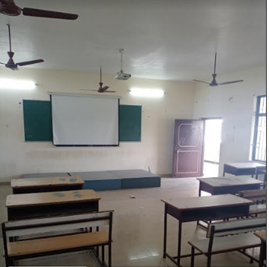
Classroom Photo of IV Yr - LHW 305

